1) Find Open ports on a system :
nmap -p ip_address or hostname

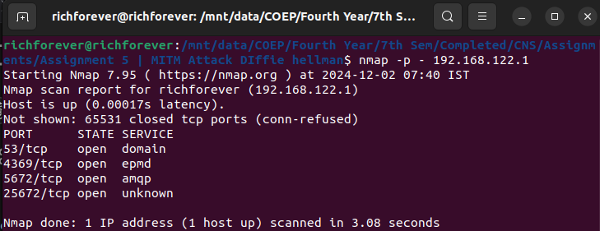

2) Find The Machines Which Are Active :
nmap -sP ip_address or hostname

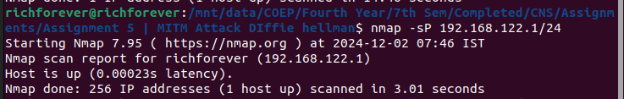

3) Find The Version Of Remote OS On Other Systems
SYN scan to detect OS : nmap -sS hostname or ip_address -O
Probable scan : nmap -sV hostname or ip_address -A

4) Find The Version Of S/W(s) Installed On Other System
nmap -sV hostname or ip_address

